## Line Clearance and Tree Trimming

1. **Line-clearance tree-trimming operations.**

This section provides additional requirements for line-clearance tree-trimming operations and for equipment used in these operations.

This section does not apply to qualified electrical employees.

1. Before an employee climbs, enters, or works around any tree, a determination shall be made of the nominal voltage of electric power lines posing a hazard to employees. However, a determination of the maximum nominal voltage to which an employee will be exposed may be made instead, if all lines are considered as energized at this maximum voltage.
2. There shall be a second line-clearance tree trimmer within normal, unassisted voice communication under any of the following conditions:
   1. If a line-clearance tree trimmer is to approach more closely than 10 feet (305 cm) any conductor or electrical apparatus energized at more than 600 volts; or
   2. If branches or limbs being removed are closer to lines energized at more than 600 volts than the distances listed in Table 2, located in WAC 296-45-325; or
   3. If roping is necessary to remove branches or limbs near such conductors or apparatus.
3. Line-clearance tree trimmers shall maintain the minimum approach distances from energized conductors given in Table 2.

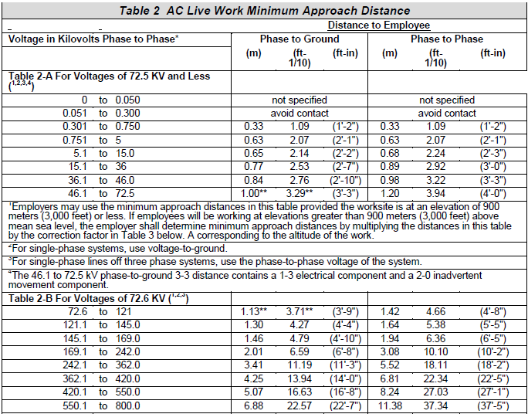

1. Branches that are contacting exposed energized conductors or equipment or that are within the distances specified in Table 2, may be removed only through the use of insulating equipment. Note: A tool constructed of a material that the employer can demonstrate has insulating qualities meeting are considered as insulated under this section if the tool is clean and dry.
2. Ladders, platforms, and aerial devices may not be brought closer to an energized part than the distances listed in Table 2.
3. Line-clearance tree-trimming work may not be performed when adverse weather conditions make the work hazardous in spite of the work practices required by this section. Each employee performing line-clearance tree-trimming work in the aftermath of a storm or under similar emergency conditions shall be trained in the special hazards related to this type of work.
4. A tree trimmer may climb out of a basket into a tree or from a tree back into the basket so long as he is properly tied into the tree during the entire maneuver and the employer can demonstrate that this is the safest way to perform the work.
5. **Brush Chippers**

This section provides additional requirements for line-clearance tree-trimming operations and for equipment used in these operations.

* 1. Brush chippers shall be equipped with a locking device in the ignition system.
  2. Access panels for maintenance and adjustment of the chipper blades and associated drive train shall be in place and secure during operation of the equipment. Servicing and maintenance shall be performed according to Lockout/tagout, control of hazardous energy.
  3. Brush chippers not equipped with a mechanical infeed system shall be equipped with an infeed hopper of length sufficient to prevent employees from contacting the blades or knives of the machine during operation.
  4. Trailer chippers detached from trucks shall be chocked or otherwise secured.
  5. Each employee in the immediate area of an operating chipper feed table shall wear personal protective equipment as required.

1. **Sprayers and Related Equipment**

Walking and working surfaces of sprayers and related equipment shall be covered with slip-resistant material. If slipping hazards cannot be eliminated, slip-resistant footwear or handrails and stair rails meeting the requirements may be used instead of slip-resistant material.

Equipment on which employees stand to spray while the vehicle is in motion shall be equipped with guardrails around the working area.

1. **Stump Cutters**
   1. Stump cutters shall be equipped with enclosures or guards to protect employees.
   2. Each employee in the immediate area of stump grinding operations (including the stump cutter operator) shall wear personal protective equipment.
2. **Backpack power units for use in pruning and clearing.**
   1. While a backpack power unit is running, no one other than the operator may be within 10 feet (305 cm) of the cutting head of a brush saw.
   2. A backpack power unit shall be equipped with a quick shutoff switch readily accessible to the operator.
   3. Backpack power unit engines shall be stopped for all cleaning, refueling, adjustments, climbing or being carried up a tree and repairs to the saw or motor, except as the manufacturer's servicing procedures require otherwise.
3. **Rope**
   1. Climbing ropes shall be used by employees working aloft in trees. These ropes shall have a minimum diameter of 0.5 inch (1.2 cm) with a minimum breaking strength of 2300 pounds (10.2 kN). Synthetic rope shall have elasticity of not more than 7 percent.
   2. Rope shall be inspected before each use and, if unsafe (for example, because of damage or defect), may not be used.
   3. Rope shall be stored away from cutting edges and sharp tools. Rope contact with corrosive chemicals, gas, and oil shall be avoided.
   4. When stored, rope shall be coiled and piled, or shall be suspended, so that air can circulate through the coils.
   5. Rope ends shall be secured to prevent their unraveling.
   6. Climbing rope may not be spliced to effect repair.
   7. A rope that is wet, that is contaminated to the extent that its insulating capacity is impaired, or that is otherwise not considered to be insulated for the voltage involved may not be used near exposed energized lines.
4. **Fall Protection**

Each employee shall be tied in with a climbing rope and safety saddle when the employee is working above the ground in a tree, unless he or she is ascending into the tree.

1. **Training and Safety**

Each employee shall be trained in the necessary skills and techniques required to work around live exposed parts. This training must be completed by a competent person. Safety briefings and tailgate meetings must take place at the beginning of each shif.